Title MODIFICATO(Arial 12 pt, bold)

F. Author¹, S. Author¹, T. Author² (Arial 11 pt, bold)

¹First affiliation, address (Times New Roman 10pt, italic), ²Second affiliation, address (Times New Roman 10pt, italic)

Email of communicating author@institution.org (Times New Roman 10pt, italic)

This document explains how to prepare an abstract for the Giornata di studio 2024 del Gruppo Italiano Geopolimeri. Abstracts should be limited to ONE PAGE of this style including figures, tables and references. Please follow the guidelines given in the following text. You should apply the styles as described here.
All paragraphs must be typed with the style Body Text (Times New Roman 10 pt), single spaced and fully justified. Space between paragraphs: 6 pt.
Begin a new paragraph on a new line with no indentation. Please format correctly any sub- ₁ and superscripts ², as well as any special symbols (greek α Ω, use ° for degrees).
Each figure should have a caption placed below the figure. Number the figures and refer to them as Fig. 1 etc. The figure layout ‘in line with text’ should be used.
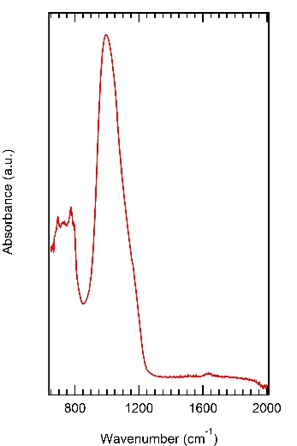

Figure 1. This is a figure caption (Times New Roman 9 pt).
References should be given in the text by square brackets [1]. Two or more references at a time may be put in one set of brackets [2-4] or [2, 3]. The references are to be numbered in the order in which they are cited in the text.
The references should be Times New Roman 9 pt and listed immediately at the end of the text without a heading.

[1] Margilies, L., Kramer, M. J., McCallum, R. W., Kycia, S., Haeffner, D. R., Lang, J. C. & Goldman, A. I. (1999). Rev. Sci. Instrum. 70, 3554.

[2] Chupas, P. J., Ciraolo, M. F., Hanson, J. C. & Grey, C. P. (2001). J. Am. Chem. Soc., 123, 1694.

[3] Bunge, H. J. (1982). Texture Analysis in Materials Science. London: Butterworth.

[4] Balzar, D. & Popa, N. C. (2004). Diffraction Analysis of the Microstructure of Materials, edited by E. J. Mittemeijer & P. Scardi, pp. 125-145. Berlin: Springer.
Acknowledgements might be included at the end of the abstract with no heading (Times New Roman 10 pt, italics).

Titolo dell’Abstract
- Font: Arial, 12pt, grassetto
- Allineamento: Centrato

Nome Autori
- Font: Arial, 11 pt, grassetto
- Allineamento: centrato

Affiliazione
- Font: Times New Roman, 10 pt, corsivo
- Allineamento: Centrato

Corpo del testo
- Font: Times New Roman, 10 pt, Normale
- Allineamento: Giustificato
- Interlinea: 1

Bibliografia
- Font: Times New Roman, 9 pt, Normale
- Allineamento: a sinistra
- Spaziatura tra voci: 6 pt

